WAG English Zone
Prepositions of Place
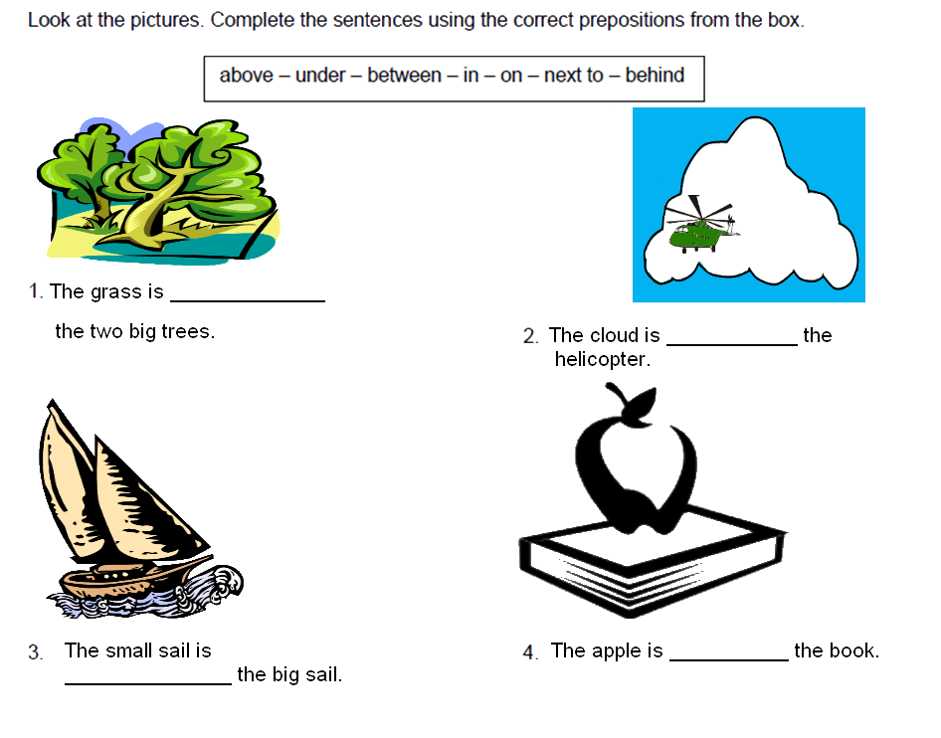
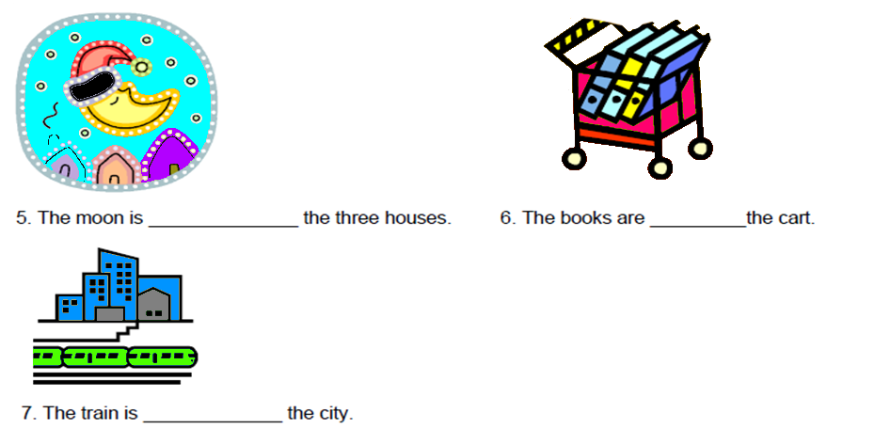
Copyright © WAG. All rights reserved.

