** WAG English Zone  Say the name of each out loud and listen for the short vowel ‘i’ sound**

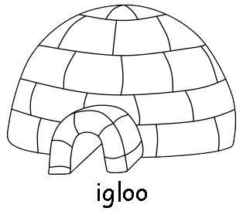 

i

 

**Ice- Cream Insect**



**Copyright © WAG All rights reserved.**