**WAG English Zone Name: ________________**

**Doing Exercises and Playing Games**

**Fill in the blanks using the words in the boxes.**

**Healthy game important interesting school**

Shamala’s mother: How do you like your P.E lessons in ___________________, Shamala?

Shamala: I like them very much! Mr.Steve, my P. E teacher, is __________ and strong. He knows many games and he teaches us one new ___________ every month. His lessons are very _______________ and we all have lots of fun.

Shamala’s mother: That’s good, it is ___________ that you exercise

every day and play games when you have the time!

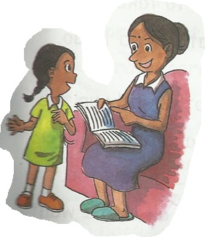

**Copyright © WAG. All rights reserved**

**WAG English Zone Name: _____________**

**The Mad Rush**

A lot of many some much a little a few

Everyday, I rush home from school. I have plenty of homework. Besides homework, I have ____________ other things to do. That is why I need to take ______________ time to write what I need to do.

For example, I have to help my mother tidy up the house. There is so ___________ dirt and dust all over the house. I have to wash ___________ dishes too. I will really need _________ time to finish all that I want to do.

I just wish I have ________________ more time to finish the things left on my list. Sigh! Sigh!

**Copyright © WAG. All rights reserved**

**WAG English Zone Name: _____________**

**Read the passage below. Put in the commas to separate words in a list.**

**What I do on Weekends.**

Hello, I am Alex.

Every Saturday, I wake up at eight o’clock in the morning. I wash my face brush my teeth comb my hair and change my clothes. Mummy buys food from the market for breakfast. I can eat  *sandwich* muffins or toasted bread.

Every Sunday night, I pack my bag before going to sleep. I make sure that my textbooks exercise books pencils pens and erasers are in my bag.

I love to go to school to play with my friends Jenny Beth George and Sam.

J:\Maragret old\Normal pics\Pics cartoonic\J0295069.WMF



**Copyright © WAG. All rights reserved**