** WAG English Zone**

Name: …………………Date: …………………. Lesson: ……………………………………

**Say the name of each out loud and listen for the ‘b’ sound.**

 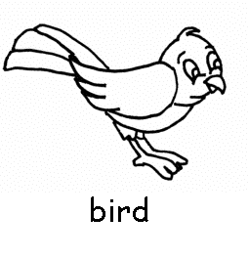 b

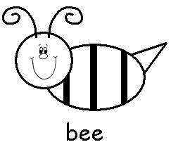 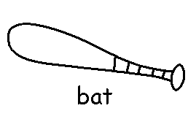

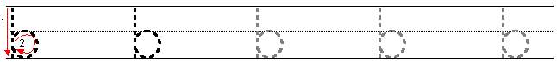



**Copyright © WAG All rights reserved.**