**WAG English Zone Name: ____________________**

Adjectives

An adjective is a describing word. It tells you more about a Noun. An Adjective usually comes before a noun it describes. Sometimes an adjective can appear after a noun.

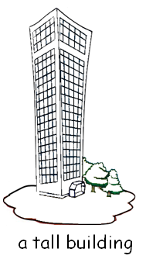

a **large** table

a **deep** well

a **busy** street

an **ugly** monster

It’s **sunny**

The baby is **cute**

All the players are **tall**

This sum is **difficult**

Darren is a **quite** boy

Sally’s writing is **neat**

The weather is **hot**

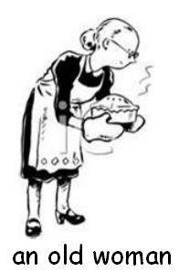 



**Copyright © WAG. All rights reserved**